**Circular linked list**

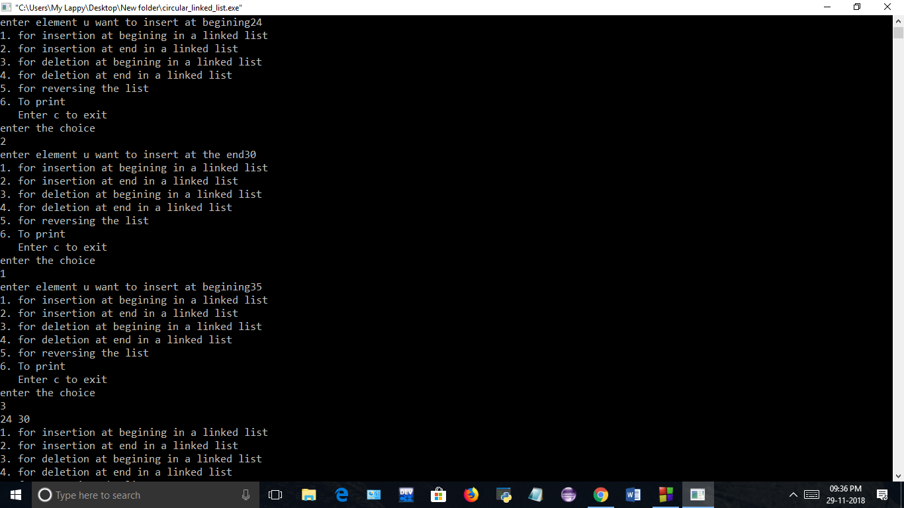

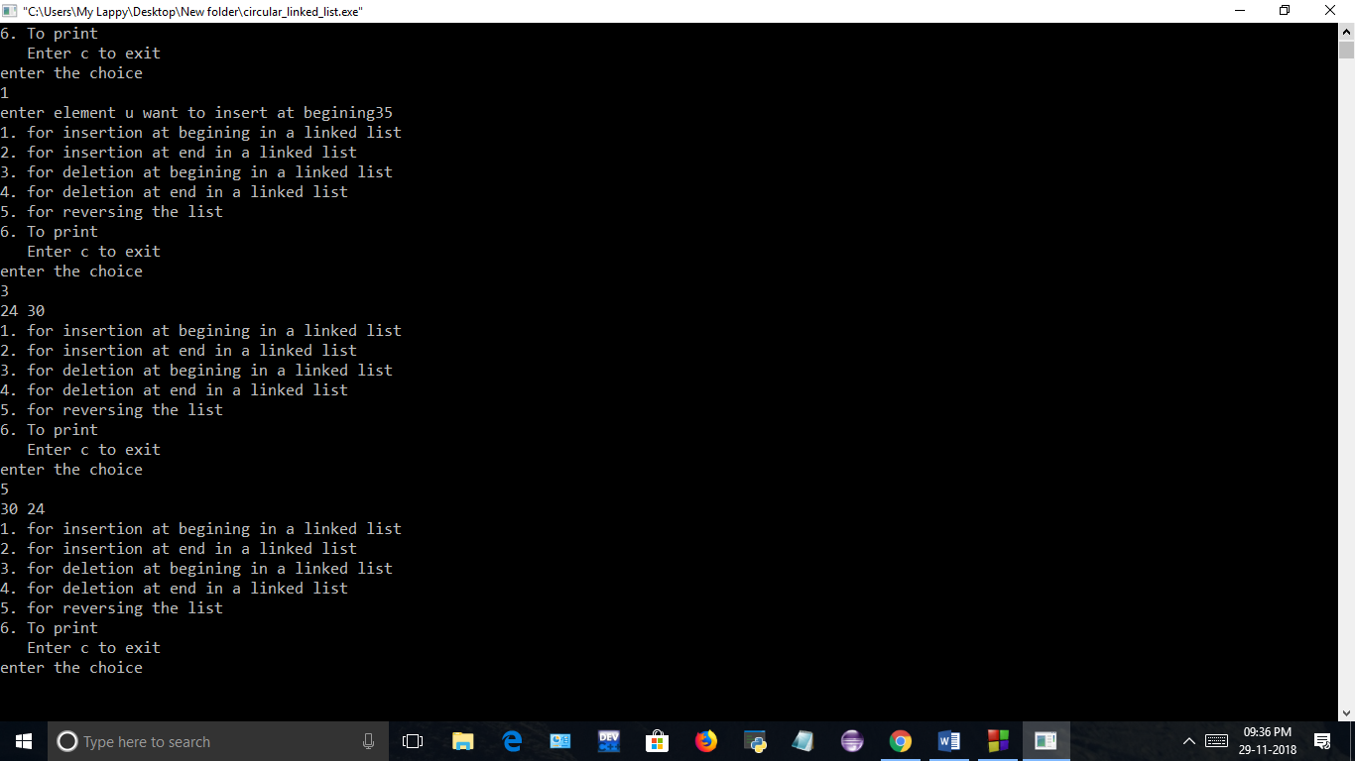

**Circular linked list(using Class)**





**Circular linked list(using class and structure)**





**Circular linked list(using structure in class)**



